Language Arts 8 MELP
Summer Reading Assignment
All Clayton Middle School MELP students who are leaving seventh grade and entering eighth grade are required to participate in summer reading. Reading over the summer is proven to help sustain and increase comprehension skills. Students who read independently become better readers and writers, have greater content knowledge, and score higher on achievement tests than those who do not.
The goals of this summer reading assignment are for students to read and enjoy a good book and maintain their reading skills over the summer. This assignment also gives students an introduction to the essential themes that our class investigates through the year: the concept of change and the hero’s journey.
When is this assignment due?
Mrs. Herbert will collect this assignment on the first day of school. On this day we will also begin discussing and exploring the novel, so it is vital to come prepared.
Step 1: Find a copy of The Adventures of Tom Sawyer by Mark Twain
You may use any edition of this novel, as long as it is unabridged. You may check the book out at the public library or purchase it if you wish. A free online copy is available through Project Gutenberg at https://www.gutenberg.org/files/74/74-h/74-h.htm.
Step 2: Read and complete Character Analysis
While you read, take notes about Tom Sawyer on the attached graphic organizer. Include text evidence and the chapter number whenever possible. Some of the entries on the chart will require inference on your part.
Step 3: Create a One-Pager Response
A One-Pager is a single-page response that shows your understanding and connection to what you have read.
Requirements:
- Project should be completed on ONE side of 8 ½ x 11 unlined sheet of paper.
- The author’s name and the title of the book should be somewhere on the front where the reader will easily notice it.
- Pull out three important quotes that jump out at you, make you think or wonder, or remind you of something. Write them anywhere on the page.
- Create a visual image (either drawn, computer-generated, or cut from a magazine) that demonstrates your understanding of the book.
- Write a 3-4 sentence personal statement about what you have read. What did it mean to you personally? What is your opinion, final thought, big question, or personal connection? What is the importance of the quotes to the text?
Examples of One-Pagers
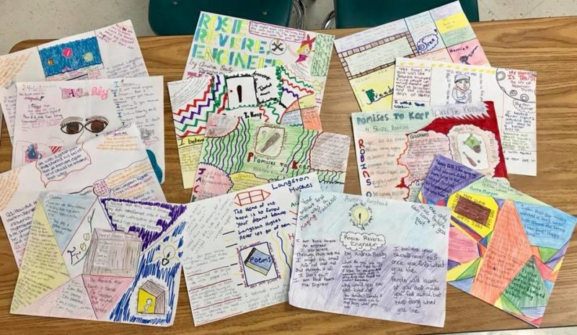
Summer Reading Assignment Rubric
 | 9-10 | 6-8 | 2-5 | 0-1
Follows Directions:  • Full Page (8½ x11)  • Unlined paper | Exemplary product  Obvious time and effort was put in to assignment | Expectations met Student followed all directions | Does not follow all of the directions | Minimal or no effort  Rushed and/or messy
Author’s Name & Title of Book | Both are easy to see | Both are included on the product | One is included | Does not include author/title
Important Quotes | Three important quotes are easy to find on the one pager | Three quotes are included | Two quotes are easy to find | Does not include quotes
Visual Image | Clearly connected to the book | Is somewhat connected to the book | Is present, but does not make a clear connection to the book | Does not include visual image
Personal Statement:  • On the Front Side  • 3-4 Sentences | Clearly connects the reader to the book with an opinion, reaction, or connection | Somewhat connects the reader to the book with an opinion, reaction or connection | Doesn’t connect the reader to the book with an opinion, reaction or connection | Does not include personal statement

Total Points: __________________/50

